AI AGENT – AGENTIC AI
The basics
- ReAct
- Planning
- Tool calling
- Memory

- ReAct (Reason + Act) – the Core Pattern
ReAct is the single most important concept behind agentic AI
ReAct = Reason (think) Act (use a tool) observer result Reason again repeat
The model alternates between:
  - Thought: internal reasoning
  - Action: choosing a tool (API call, code run, DB query)
  - Observation: reading tool output
  - Then repeating until done
Why is it important? Without ReAct, the model is a static one-shot LLM.
With ReAct, the model becomes an interactive agent that can:
  - Plan
  - Gather information
  - Correct mistakes
  - Call tools
  - Adapt
🧱 A simple ReAct Schema:

- Planning – how the agent breaks down tasks
Planning is how the agent decides the steps
Two main planning patterns:
- Decompose-first (Planner Agent):
The agent first breaks the task into steps, then executes:
- Search topic
- Extract key points
- Check facts
- Summarize concisely
Then it executes step-by-step.
Used in: AutoGen, CrewAI, LangGraph
Strengths: More reliable, easy to debug, good for long tasks
- Dynamic (ReAct-based) Planning
The agent plans on the fly (plan as it goes), step by step:
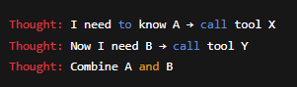
Used in: OpenAI Agents API
Strengths: More flexible; handles complex, unknown workflow

🔧A simple rule:
  - Plan (Decompose-first) if task is big
  - ReAct (Dynamic planning) if task is exploratory

- Tool Calling – how agents actually DO things
Tool calling = the agent calling code or APIs.
This is the engine that lets agents be more than “chatbots.”
A tool is just a function with a schema
For example, we have a python function get_weather:
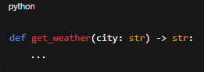
The agent can automatically call: 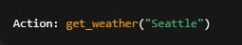

Common tool types:
    - Python code interpreter
    - Search functions
    - HTTP requests
    - Database queries
    - Filesystem operations
    - Custom business logic
    - Third-party API wrappers
In the OpenAI Agents API and LangChain, the model when to call a tool vs. when to response normally.
Tools = Capabilities
If you give an agent a tool that can:
    - Create files
    - Push git commits
    - Run docker
    - Send email
    - Edit documents
The agent can literally do those things autonomously.
❗ Key developer mindset:
Agents don’t “know” how tools work; they learn behavior from examples + formats.
If tool calling is unreliable, it’s almost always due to:
    - Unclear schema
    - Weak instructions
    - Bad naming
    - Missing Examples
So overall, our (human) faults. Not model failure.

- Memory – short & long-term
Memory gives agents state and the ability to work over long tasks.
There are 2 categories:
- Short-Term Memory (STM):
Temporary scratchpad during a task.
Forms:
    - ReAct “Thought” traces
    - Chat history
    - Task plan
    - Intermediate tool outputs
    - Model’s own reasoning
Used to:
    - Keep context
    - Revise earlier steps
    - Track progress
- Long-Term Memory (LTM)’
Persists across tasks/sessions.
Forms:
    - Vector DB (embeddings)
    - JSON store
    - Sqlite/postgres
    - File-based memory
    - Custom memory tool
Used for:
    - Knowledge retention
    - User preferences
    - Multi-day tasks
    - Project knowledge
    - File indexing
🧠 How memory is used in agent systems
The memory loop:
- Retrieve relevant memory
- Use it in planning
- Add new experiences
- Update memory store
This is how agents evolve over time.
Example from developer workflow:
An agent can remember:
    - How your repo is structured
    - How to write tests in your style
    - Which frameworks you prefer
    - Past errors + their fixes
This is how “dev agents” get smarter
As an AI Agent Engineer, you use BOTH together:
Agent loop:
- Retrieve relevant LTM entries load into STM
- ReAct reasoning using STM
- Produce answer
- If valuable write back to LTM
This is how “intelligent” behavior emerges.

Some questions:
So Short-Term memory is almost like caches? It keeps track of context that recently happen so that it remember contexts and such? Like openAI chatgpt needs this so that its response is relevant to the user's recent messages? While long term memory is almost like a database? When to use which?
Answers:
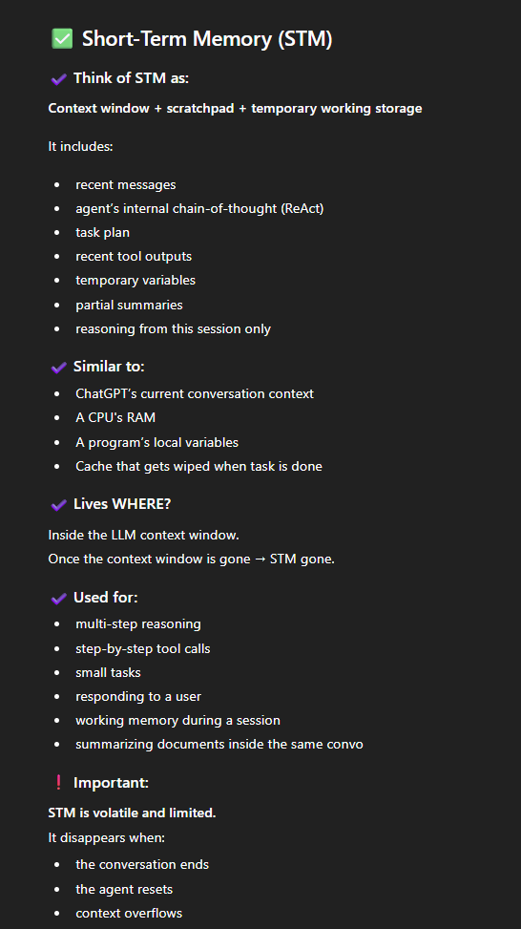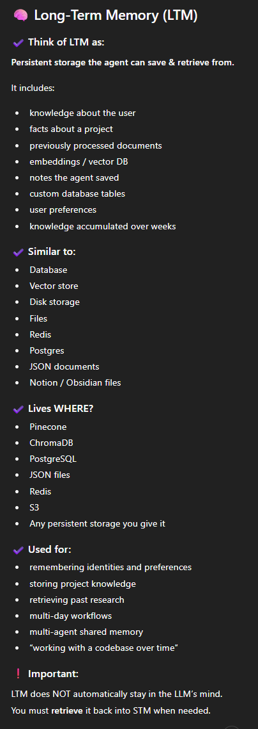
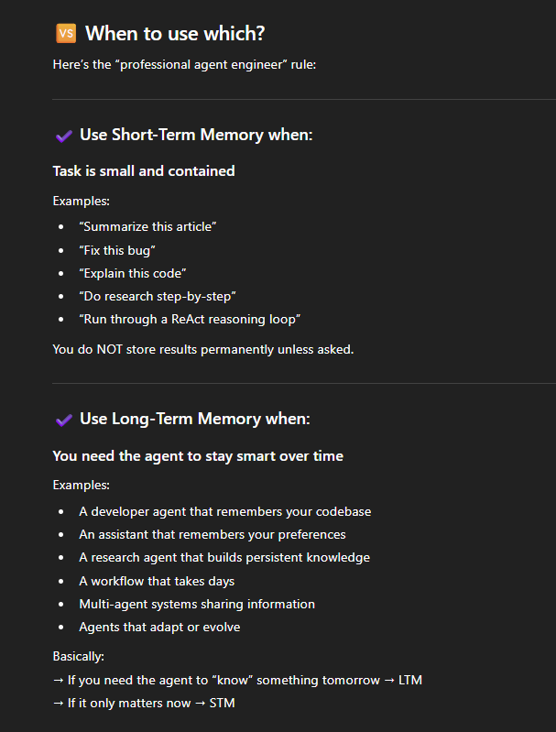
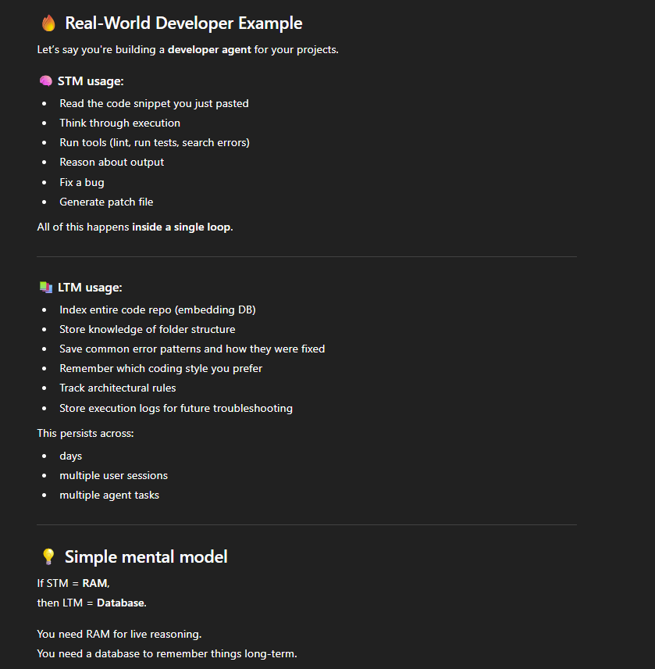

🧠 DAY 1–2 KNOWLEDGE TEST
Part 1 — Concept Checks (Short Answer)
Answer each briefly (1–2 sentences max):
1. ReAct
Q1: Why is ReAct necessary for building AI agents, instead of just calling the LLM once?
ReAct is necessary because the AI model would be able to have several steps (a loop) of processing: from thoughts/reasonings -> action -> observation -> repeat. If calling LLM once, we simply get an output and that's it (because that's what LLM does: input -> LLM -> ouput; done).
Q2: In the ReAct loop, what is the difference between “Thought” and “Observation”?
Thought is the process of internal reasoning; the ai thinking and making decision. Observation is the process of reading/analyzing the output from its action to see what's wrong, what's right, what further action to take (to do the loop again/think again)
Q3: If a tool call returns an unexpected error, where does the agent actually store that information? (STM or LTM?)
The error would be stored in STM. It’s because an unexpected error is a recent context that the AI need to evaluate, so storing in STM for context would be good. However, I think if the error is to be a hard-to-fix, can't be solved immediately, maybe it can be written to LTM, waiting for human's intervention.

Part 2 — Planning (Explain the Logic)
Q4: When should you use decompose-first planning instead of dynamic planning?
We use decompose-first (instead of dynamic planning) when we're given a big, multiple-days task. Also used when you need reliability/debuggability
Decompose-first = big tasks, lnog workflows, multistep predictable processes, tasks where errors are expensive.

Q5: Why is ReAct considered a “dynamic planner”?
ReAct is considered a "dynamic planner" because ReAct is basically a loop of steps (think -> act -> observe), while dynamic planning is the pattern of "plan on the fly/plan as we go," which aligns with ReAct's mechanism.

Part 3 — Tool Calling (Practical Understanding)
Q6: You provide an agent with this tool:
def check_weather(city: str, units: str):
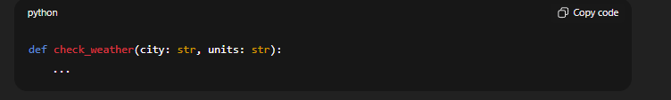Why must you define a schema for this tool before the agent can reliably call it?
Because if we don't have a fixed and firm schema (a structure I assume), the AI might not be consistent with calling it (passed in inconsistent parameters at different times).
Without schema, the agent cannot:
- know argument names
- know argument types
- know permitted values
- call the tool consistently
Q7: If an agent repeatedly calls a tool incorrectly, what is the MOST likely cause?
(choose one)
A. The model is too small
B. The tool schema is unclear
C. The LLM is hallucinating
D. The tool name is too long

Part 4 — Memory (Deep Understanding)
Q8: Give one example that should be stored in Short-Term Memory and one example that belongs in Long-Term Memory.
Short term memory example scenario: User's recent request/question LTM Example scenario: User's context like his or her name, his or her project, things to be stored in a DB like a user's address, favoriteStation, etc. etc. depending on context of the app
Q9: Why can’t you “trust” STM to remember important things, even in a long conversation?
Because STM is volatile and limited. It disappears when the conversation ends, the agent resets, or context overflows (Too much information in a session) -> it will become fuzzy and inconsistent.
Q10: Explain—in your own words—the cycle of how an agent uses STM + LTM together in a multi-step task.
When a session begins, Ai Agent retrieve relevant LTM entries -> load into STM. The AI use reAct reasonning with that loaded STM, produce answers to whatever the user has requested/asked, and if the answers are valuable, then write it back to LTM for long-term storing.

Part 5 — Applied Scenario
Read this scenario and answer 2 questions.
You’re building a “Developer Agent” that fixes bugs in your Node.js repo.
The user asks:
“Fix the bug in /src/utils/formatDate.js. It crashes when input is null.”
The agent will:
- Read the file
- Plan how to fix the code
- Call a code tool
- Produce a patch
- Remember what files it has seen
Q11: Which steps MUST be handled with Short-Term Memory, and why?
The steps must be handled with short-term memory are:
- Read the file: storing the file context in STM to know what to do next.
- Plan how to fix the code: store in STM to act accordingly with the planning
- Call a code tool
Sums-up: STM MUST STORE:
✔ reading the file
✔ tool outputs
✔ current plan
✔ code diff being produced
✔ errors
✔ reasoning
❌ "Remember what files it has seen" is actually LTM
Unless it's only relevant for this one task.
If the agent needs:
- familiarity with the repo structure
- understanding project architecture
- persistent knowledge of file locations
→ that’s LTM, not STM.
Corrected:
STM:
- file content
- local reasoning
- tool results
- step-by-step plan
LTM:
- list of files in repo
- previous fixes
- common bugs
- architectural patterns
✔ Score: 9/10 (minor correction)

Q12: What information (if any) should be written to Long-Term Memory so the agent improves over time?
The step must be handled with LTM:
- Produce a patch: if the patch/answer is valuable, store it in LTM for future improvement/references.
- Could we also store the "Plan how to fix the code" in the LTM for future improvement if possible?
BUT IT DEPENDS THO.
Should we store:
- patches?
- plans?
Correct answer: It depends.
Write to LTM ONLY IF:
- the fix represents a reusable pattern
- it’s knowledge that will matter later
- the agent will apply this style next time
- it helps codebase understanding
For example:
✔ patterns of null-check fixes
✔ mapping of file responsibilities
✔ bug-category knowledge
✔ reusable patch templates
But:
❌ you don’t store every patch blindly (LTM becomes noisy)
❌ you don’t store local reasoning (belongs to STM)

